CS-255
Professor Foss
Billy Lewis
February 5, 2026

Project One: Business Requirements Document – DriverPass

System Components and Design
The DriverPass system is a web-based application designed to support driver education through online practice exams and on-the-road training. The system will consist of a user-facing web interface for students and instructors, as well as an administrative back end for management and IT staff. Core components include user account management, lesson scheduling, practice exam delivery, progress tracking, reporting, and data storage. The system will integrate with third-party services for secure payment processing and notifications.

Purpose
The purpose of the DriverPass system is to improve student success rates on driving license exams by providing structured online practice tests and on-the-road driving instruction. The system will allow students to prepare more effectively, instructors to manage lessons efficiently, and administrators to oversee operations, reporting, and system maintenance.

System Background
DriverPass identified a gap in existing driver education tools, noting that many students fail licensing exams due to relying solely on studying previous tests. DriverPass seeks to address this problem by offering a comprehensive system that combines online learning with practical driving instruction. The new system will replace manual scheduling and fragmented tools with a centralized platform that supports students, instructors, and management.

Objectives and Goals
The primary objectives of the DriverPass system are to:
- Increase student pass rates for driving exams
- Provide flexible online practice exams accessible from anywhere
- Support scheduling and management of on-the-road driving lessons
- Enable instructors to track student progress
- Provide administrators with reporting and oversight tools
- Ensure data security, accuracy, and system reliability

Requirements

Nonfunctional Requirements

Performance Requirements
- The system must support multiple concurrent users without degradation.
- Practice exams and scheduling features must load within acceptable response times.
- System uptime should be maintained at a high level to ensure availability.

Platform Constraints
- The system must be web-based and accessible via modern web browsers.
- The system should support both desktop and mobile access.
- The system must integrate with third-party payment providers.

Accuracy and Precision
- Student scores and progress data must be calculated accurately.
- Scheduling data must prevent double-booking of instructors or vehicles.
- Reports must reflect real-time and historical data correctly.

Adaptability
- The system should allow for future expansion, such as additional training modules.
- Updates to exam content should be easily managed without system downtime.
- The system should support changes in regulatory requirements.

Security
- User authentication must be required for system access.
- Student and payment data must be securely stored and transmitted.
- Role-based access control must restrict administrative functions.

Functional Requirements
- Students must be able to create and manage user accounts.
- Students must be able to take online practice exams.
- Students must be able to schedule and track on-the-road lessons.
- Instructors must be able to manage availability and lesson schedules.
- Administrators must be able to manage users, content, and reports.
- The system must track student progress and exam results.
- The system must generate reports for management review.

User Interface
- The system must provide an intuitive dashboard for students.
- Instructors must have access to scheduling and student information views.
- Administrators must have access to management and reporting interfaces.
- The interface must be user-friendly and accessible to non-technical users.

Assumptions
- Users will have reliable internet access.
- Instructors will enter accurate availability information.
- Third-party payment services will handle financial transactions.
- Users will access the system using supported web browsers.

Limitations
- The system does not replace official government driving exams.
- The system depends on third-party services for payment processing.
- Initial versions may have limited reporting capabilities.
- Mobile access may have reduced functionality compared to desktop access.

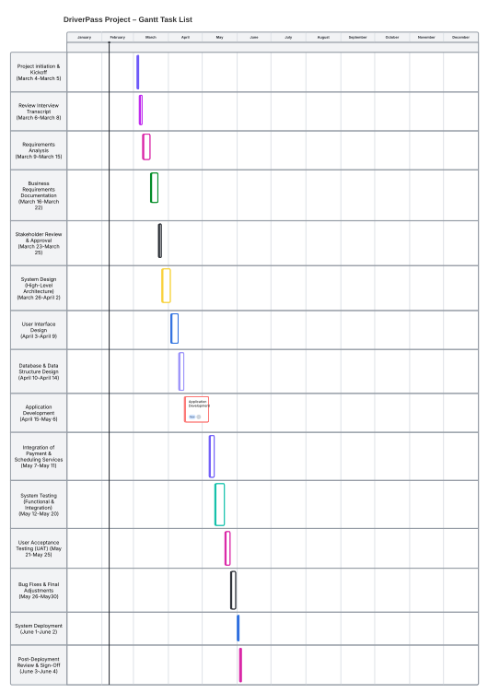
Figure 1. Figure 1 shows the high-level project schedule for the DriverPass system, outlining key phases from requirements analysis through deployment.

